Project Report Template

Build a Employee Travel Approval Application for corporate

1. INTRODUCTION
   1. **Overview**

Travel approval is a procedure using which organizations enforce travel policies and prevent employees from overspending. Travel expense approval workflows can eliminate bottlenecks in the process, help boost efficiency and improve workplace productivity. A travel request form helps gather employee trip details and allows you to reject or approve their travel and reimburse their expenses.

* 1. **Purpose**

One of the main reasons why business travel is important is the personal interaction that builds goods foundations for a future or existing relationship. This can also reduce miscommunication, and encourage almost a sense of unity.

1. Problem Definition & Design Thinking
   1. **Empathy Map**

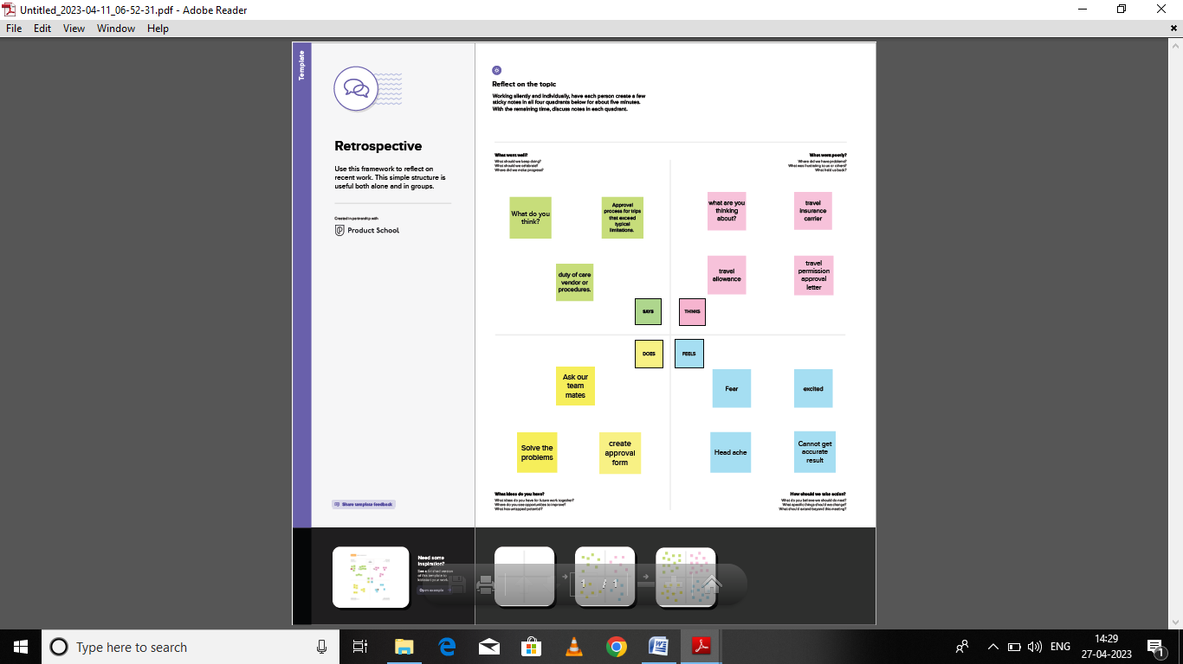

**2.2 BRAINSTROM**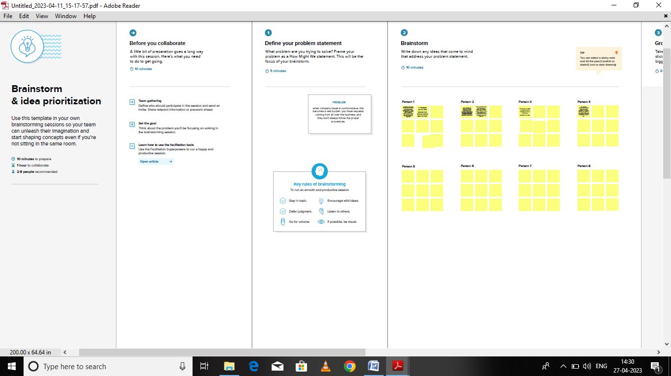

**2.3 GROUP IDEAS**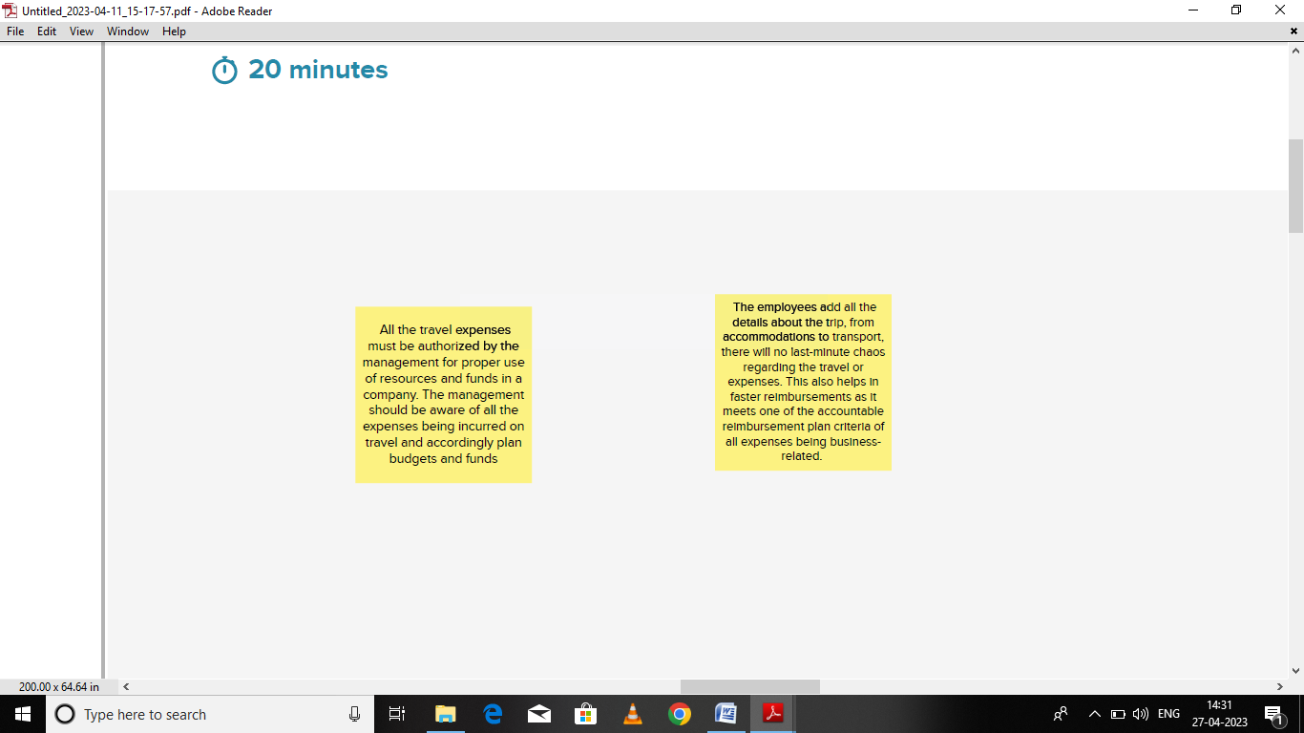

* 1. **PRIORITIZE**

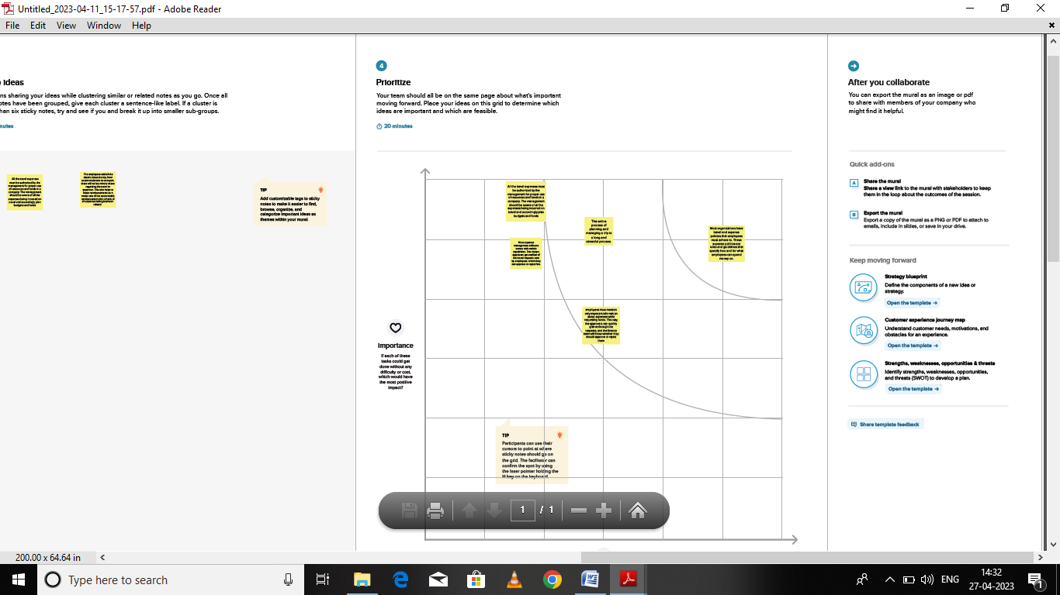

1. RESULT

**3.1 DATA MODE**

|  |  |  |
| --- | --- | --- |
| **OBJECT NAME** | **FIELD IN THE OBJECT** | |
| Department | **Field lable** | **Data type** |
| [Department Code](https://mindful-hawk-q9avwo-dev-ed.trailblaze.lightning.force.com/lightning/setup/ObjectManager/01I5i000002AW4H/FieldsAndRelationships/00N5i00000KlP7s/view) | Text(10) (Unique Case Sensitive) |
| Expence Item | **Field lable** | **Data type** |
| Amount | Currency(16, 2) |
| Expense Type | Picklist |
| Travel Approval | Master-Detail(Travel Approval) |
| Travel Approval | **Field lable** | **Data type** |
| Department | Lookup(Department) |
| Destination State | Text(2) |
| Out-of-State | Checkbox |
| Purpose of Trip | Text Area(255) |
| Status | Picklist |
| Status Indicator | Formula (Text) |
| Total Expenses | Roll-Up Summary (SUM Expense Item) |
| Trip End Date | Date |
| Trip Start Date | Date |

**3.2 Activity and Screenshot**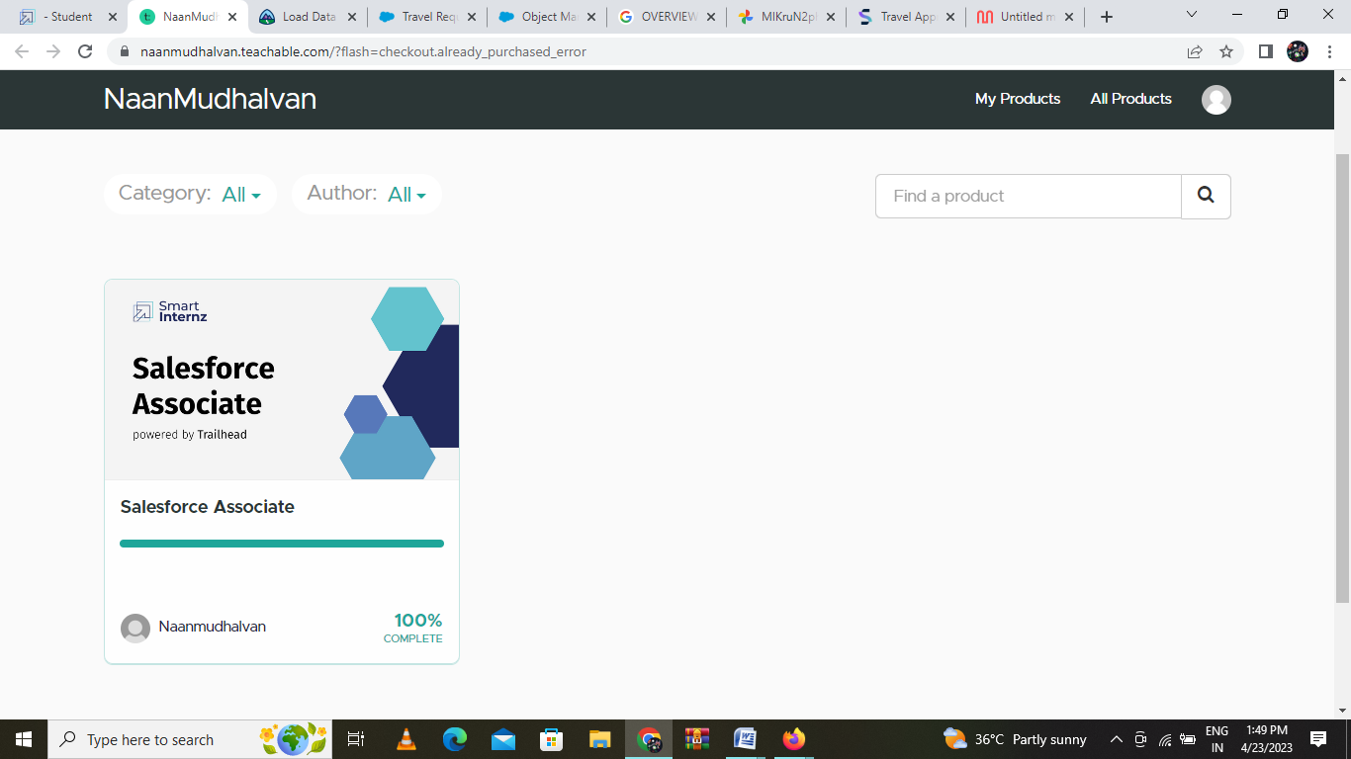

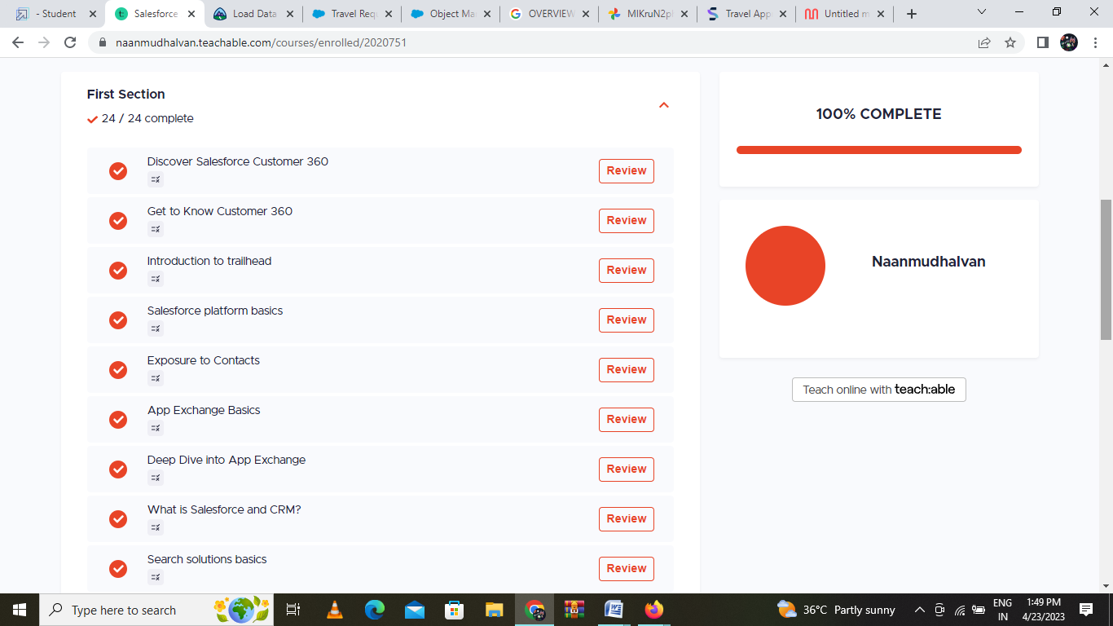

**Milestone 1- Create Salesforce Org:**

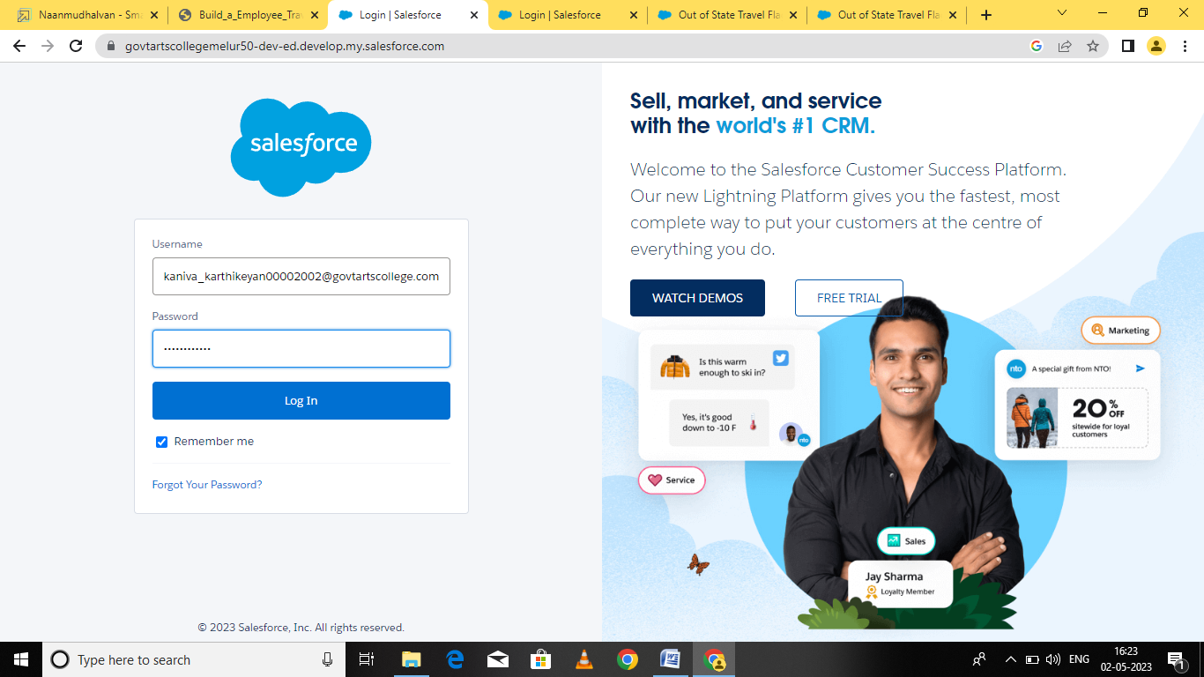

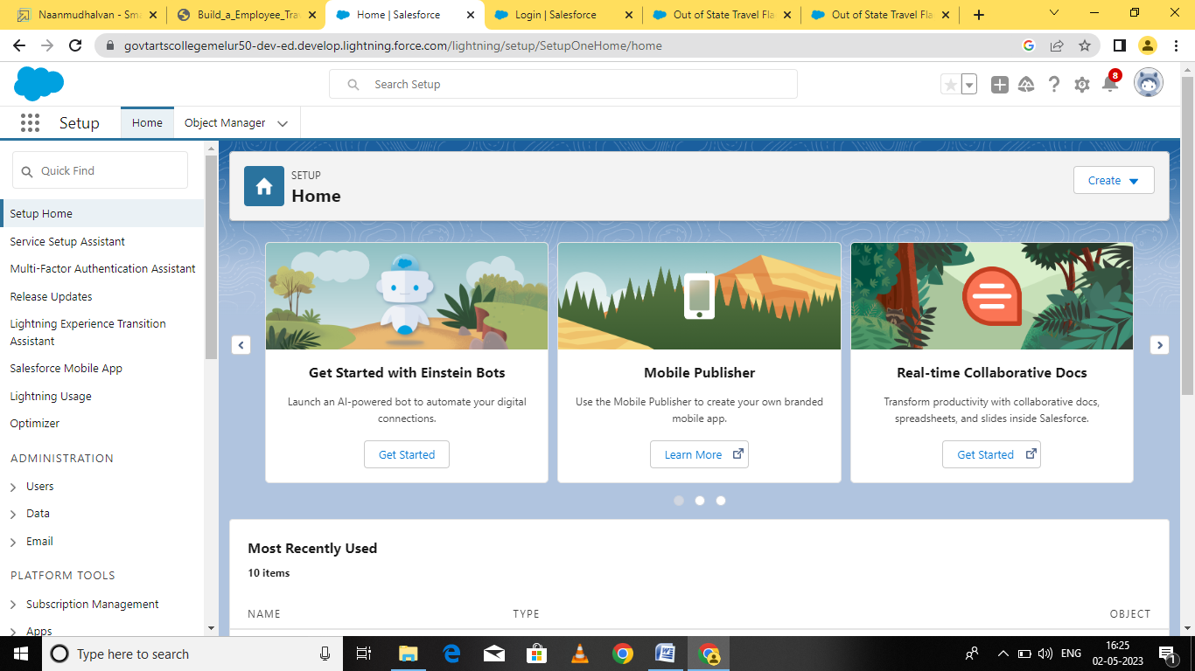

**Milestone 2 Creating the Application:**

Activity-1: Create the Travel Application

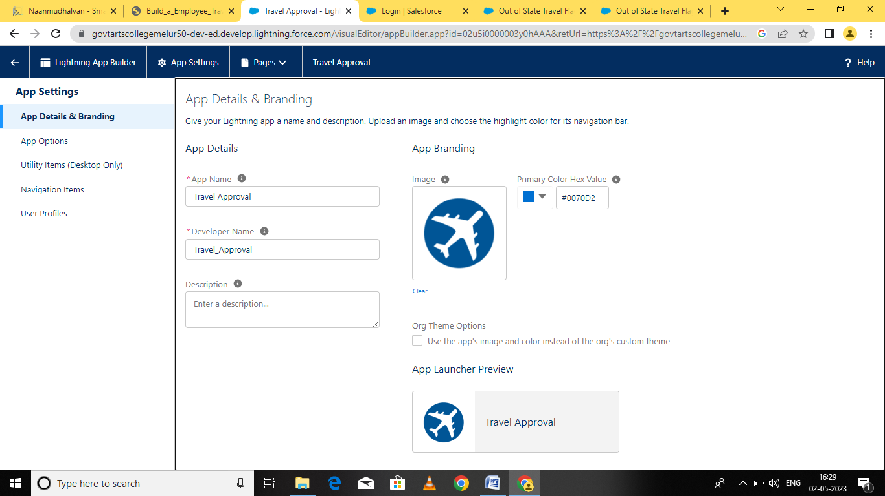

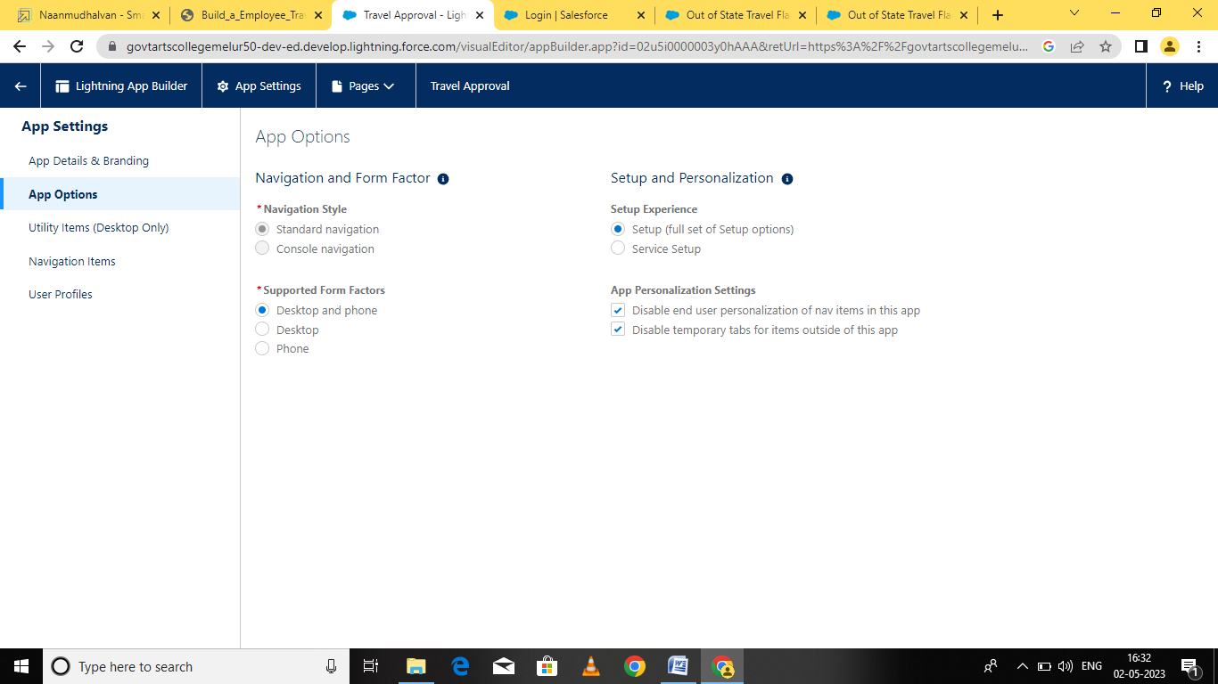

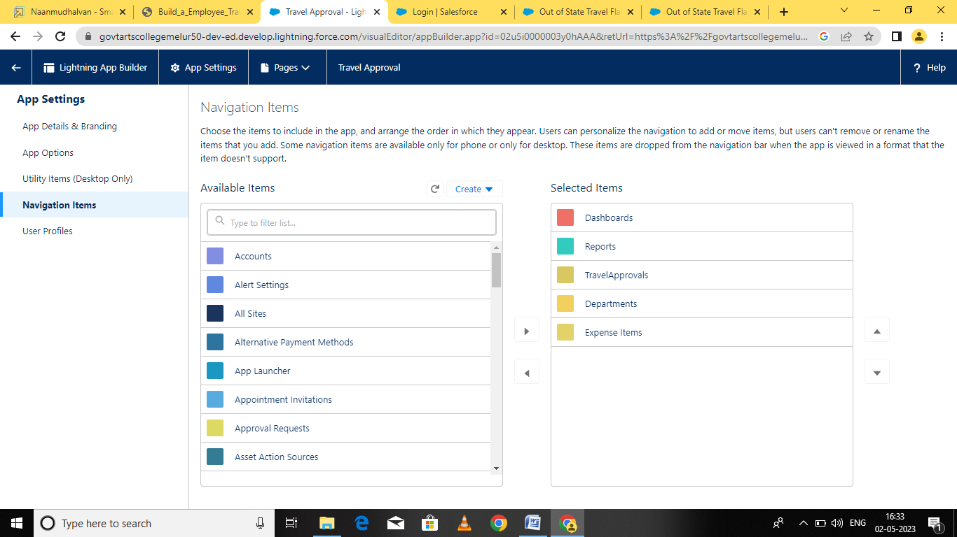

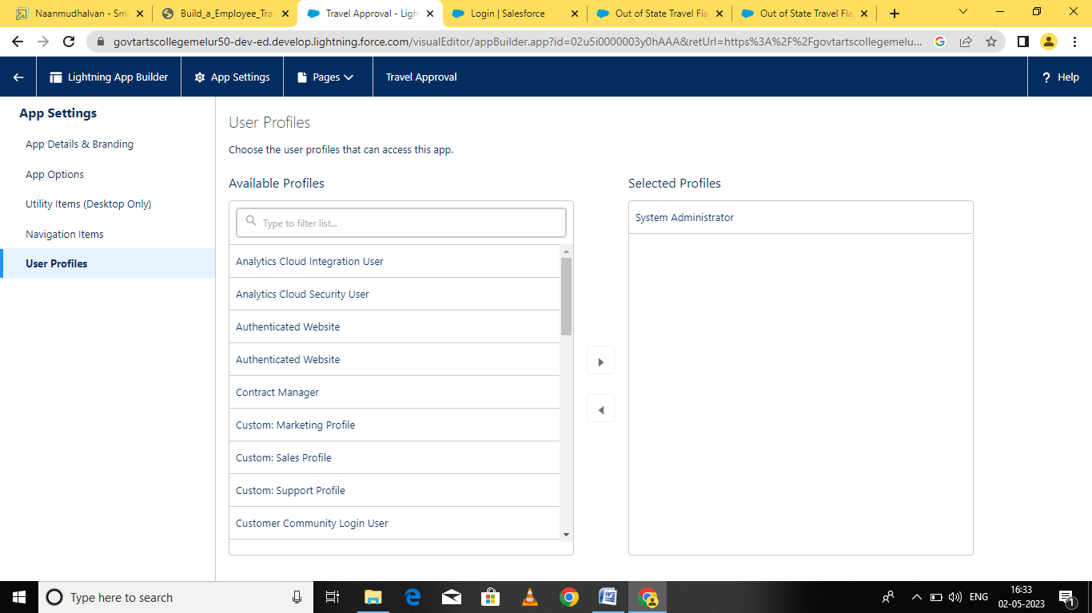

**Milestone 3**

Activity-1: Custom Object Creation

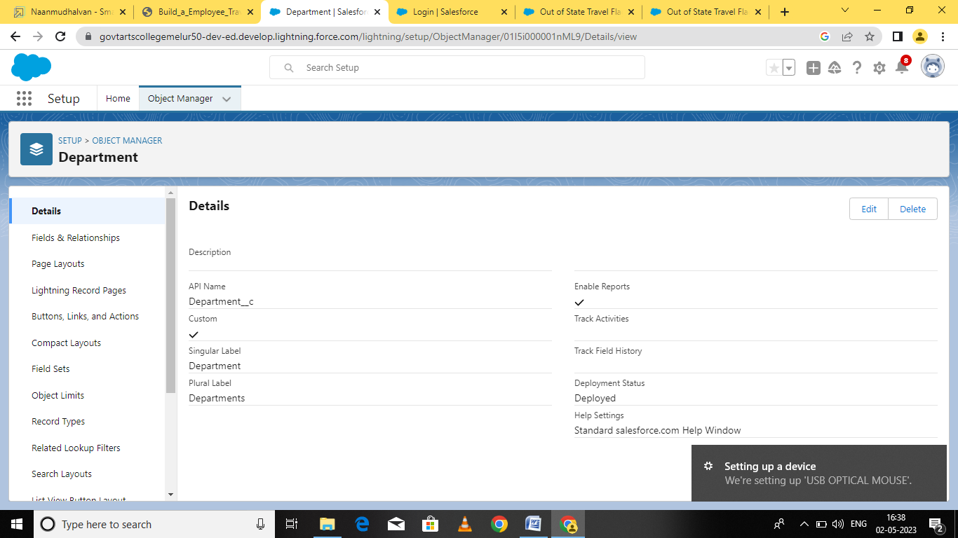

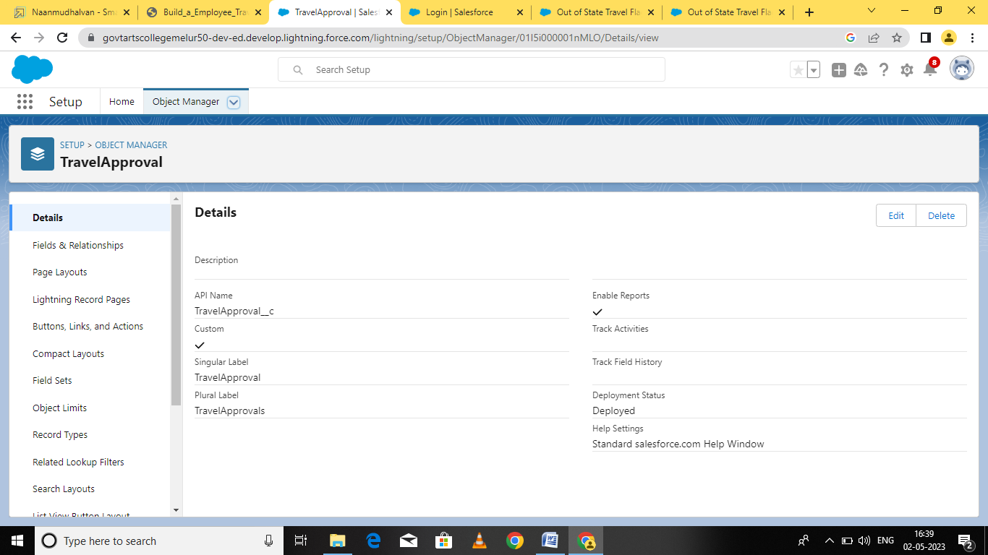

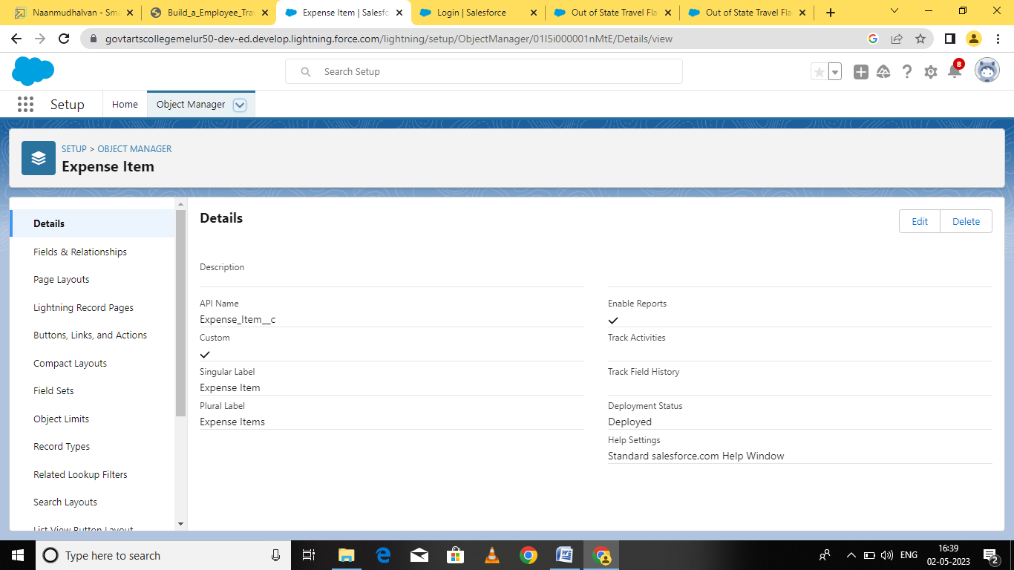

**Activity-2:**

Create 3 custom objects and tabs

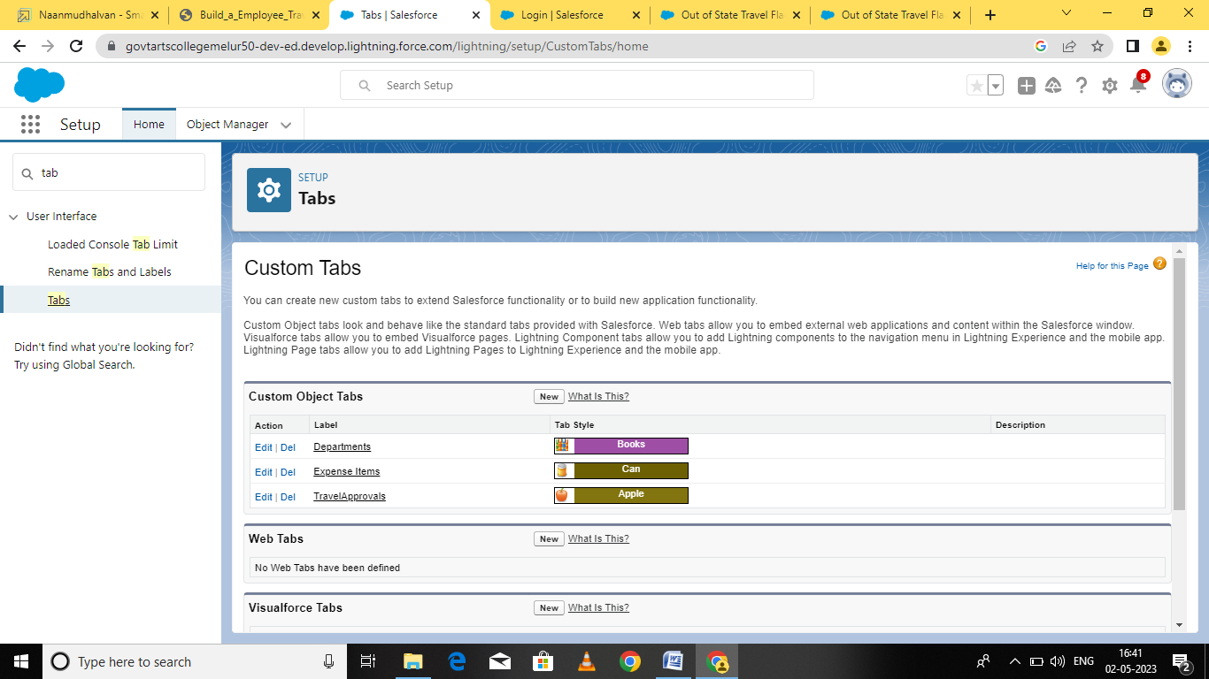

**Milestone 4 Create- Fields& Relationships :**

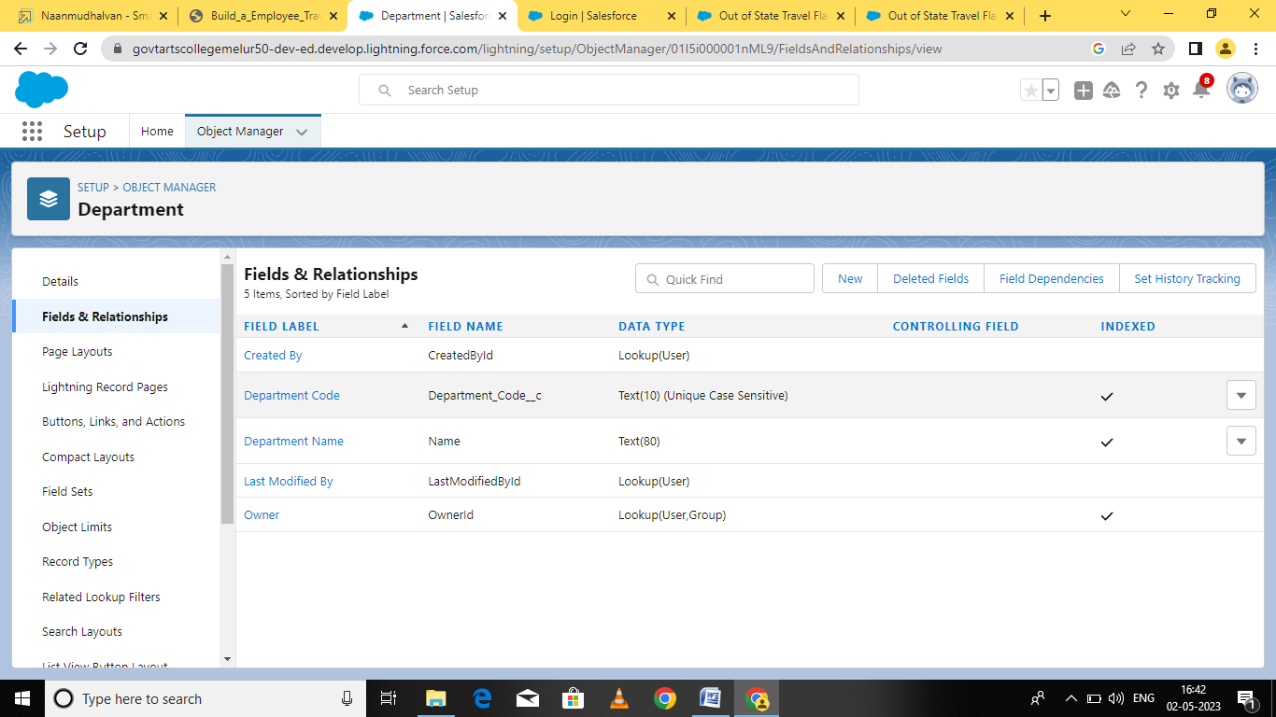

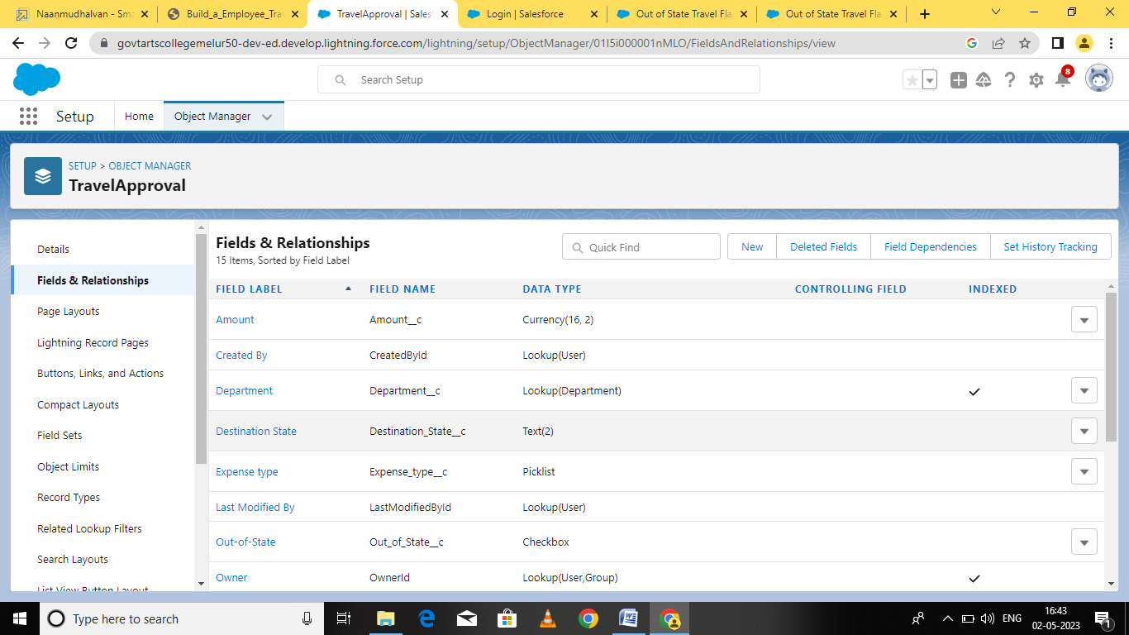

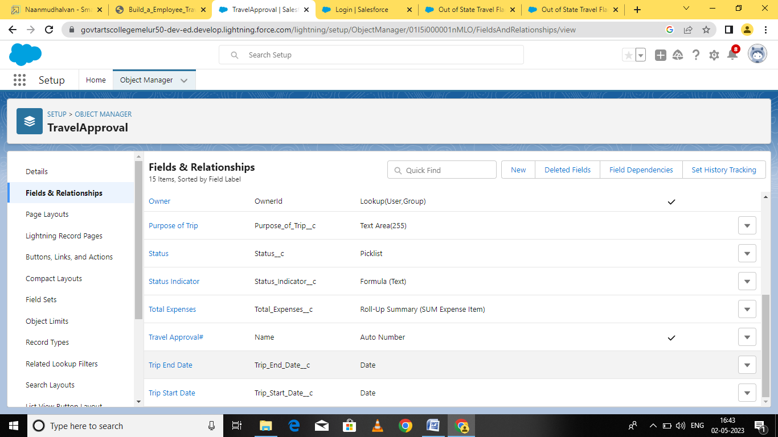

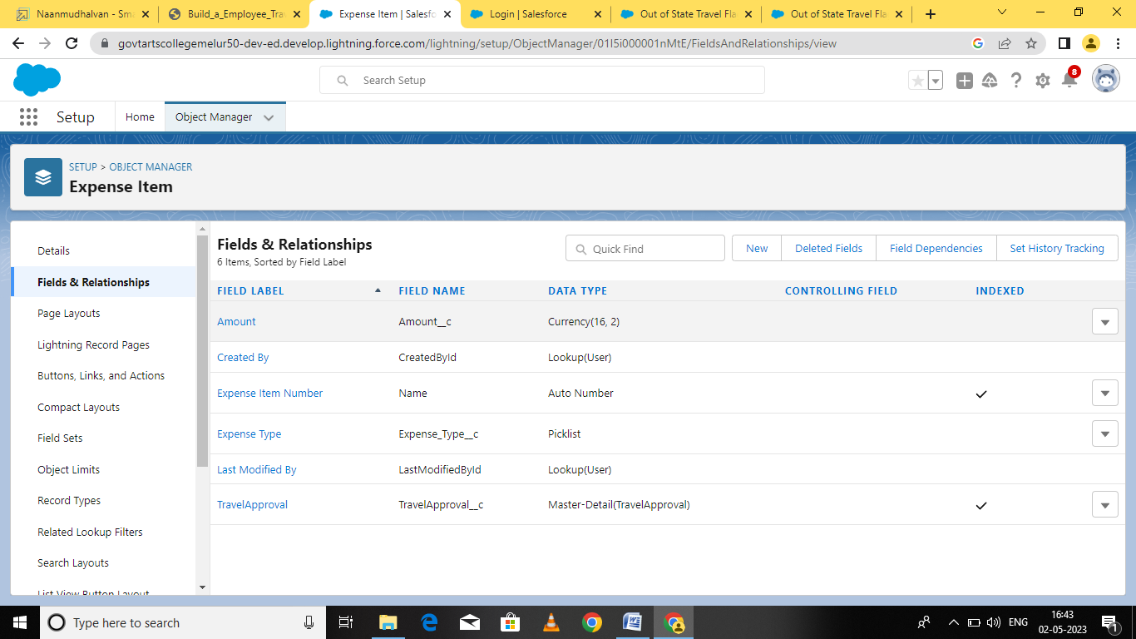

**Milestone 5-Import Departments**

Activity-1:

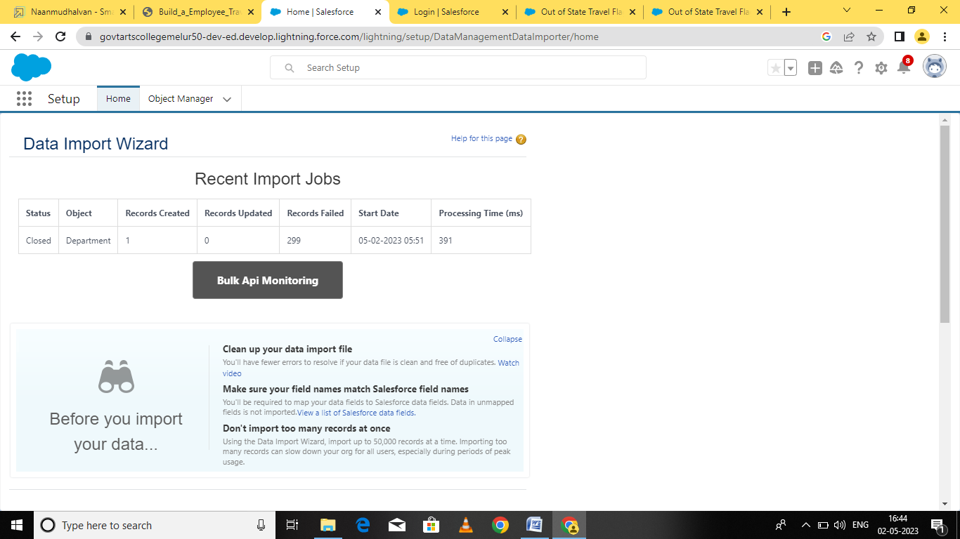

**Milestone 6-Customize User Interface**

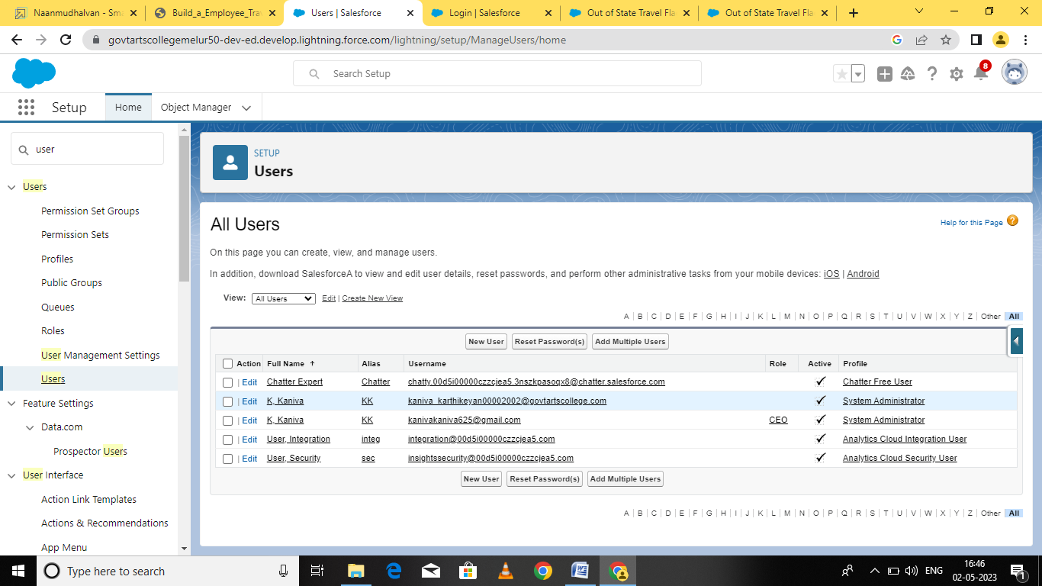

**Milestone 7- Use customization**

Activity -1: Customize Travel Approval Object Page layout

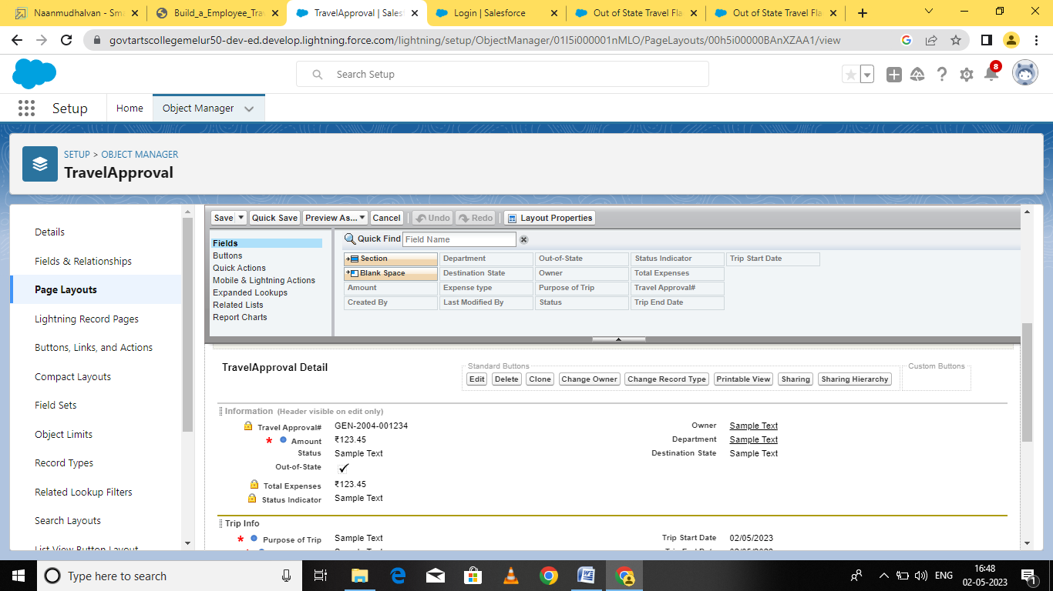

**Milestone 8-Add Business Logic to Travel App**

Activity-1: Create Validation Rule

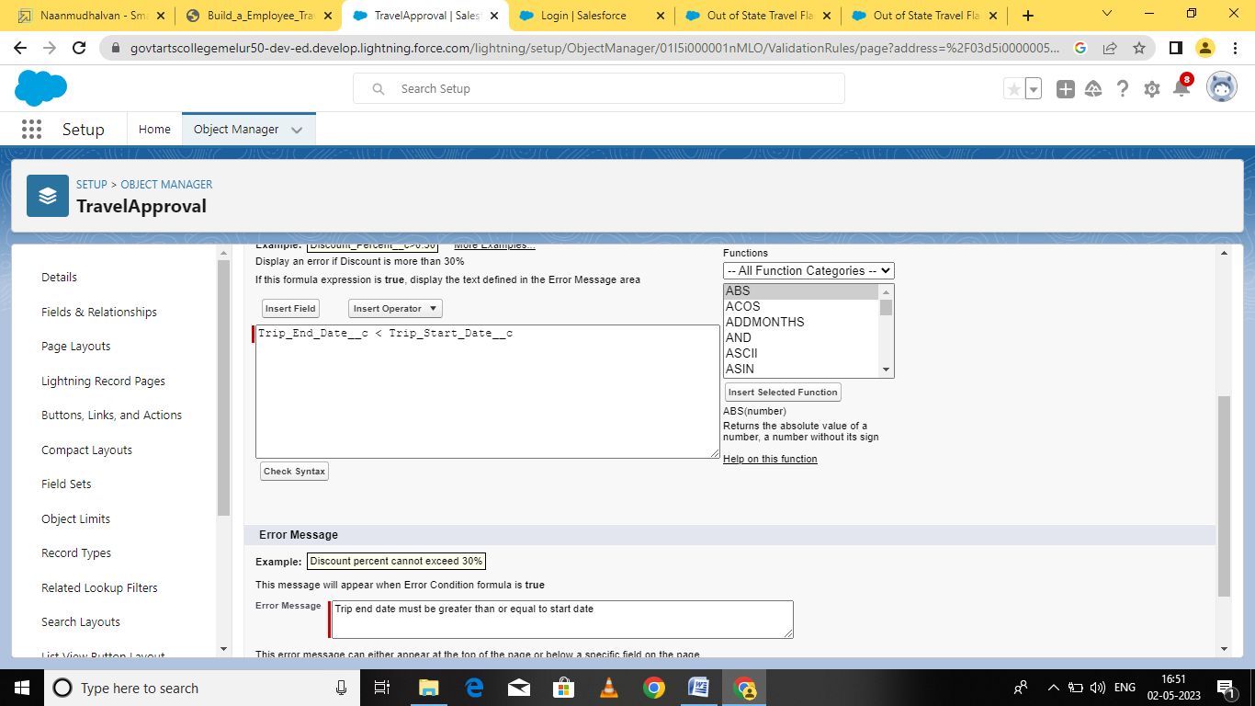

Activity-2: Create RollUp Summary Fields

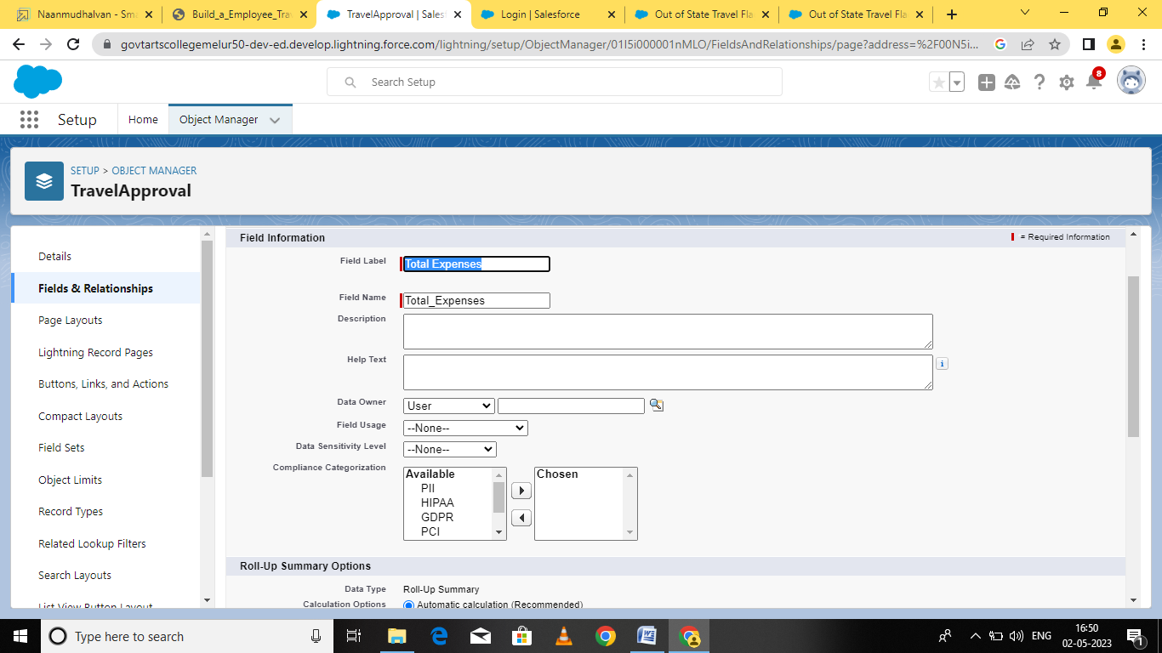

Activity-3: Create Formula Fields

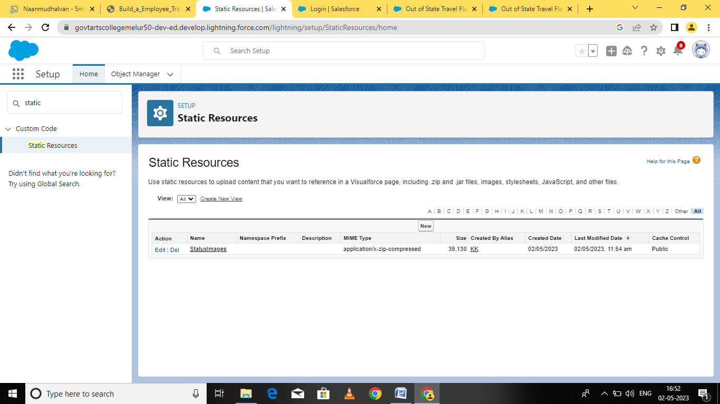

**Milestone 10**

Activity Add Report

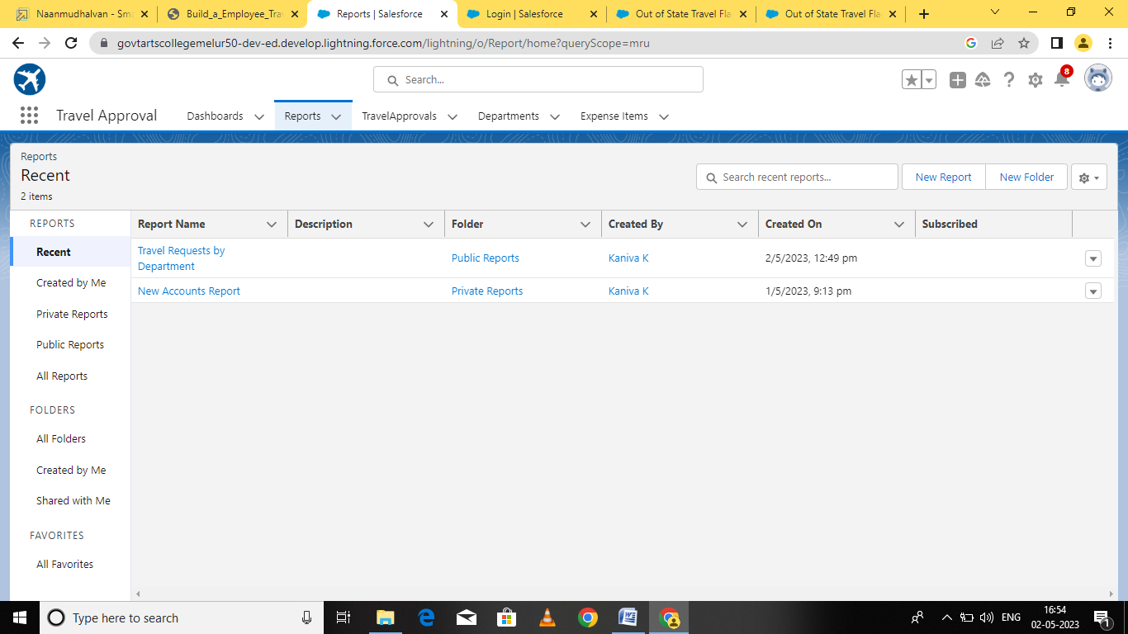

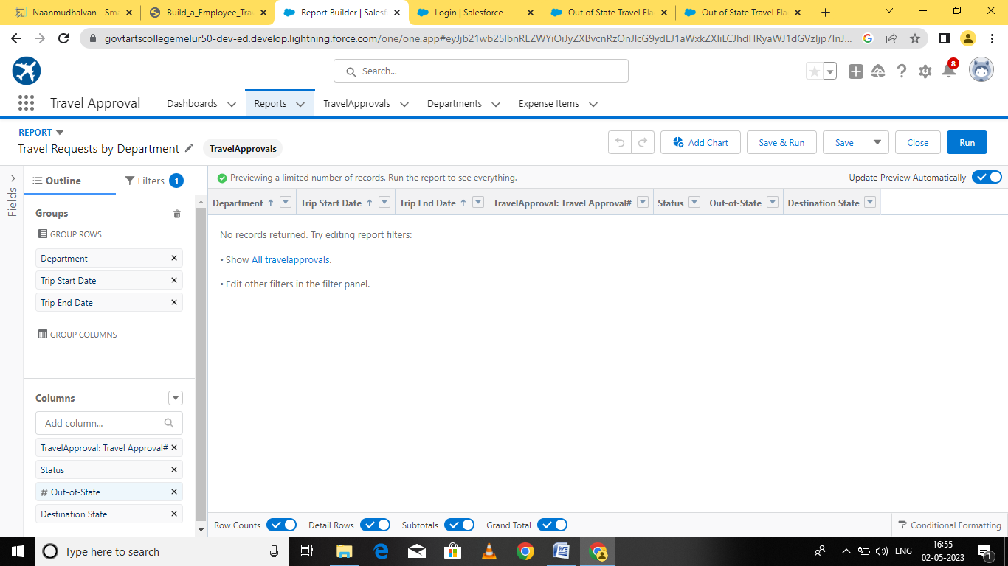

**Milestone 11- Dashboards:**

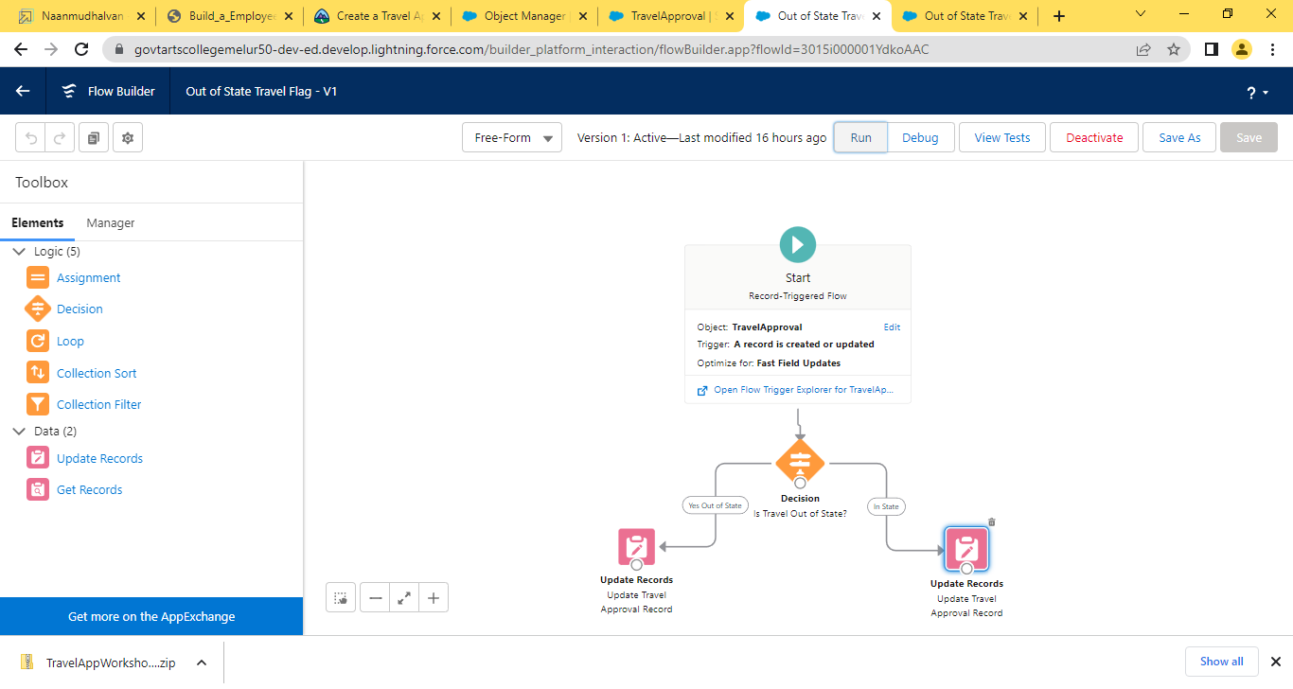

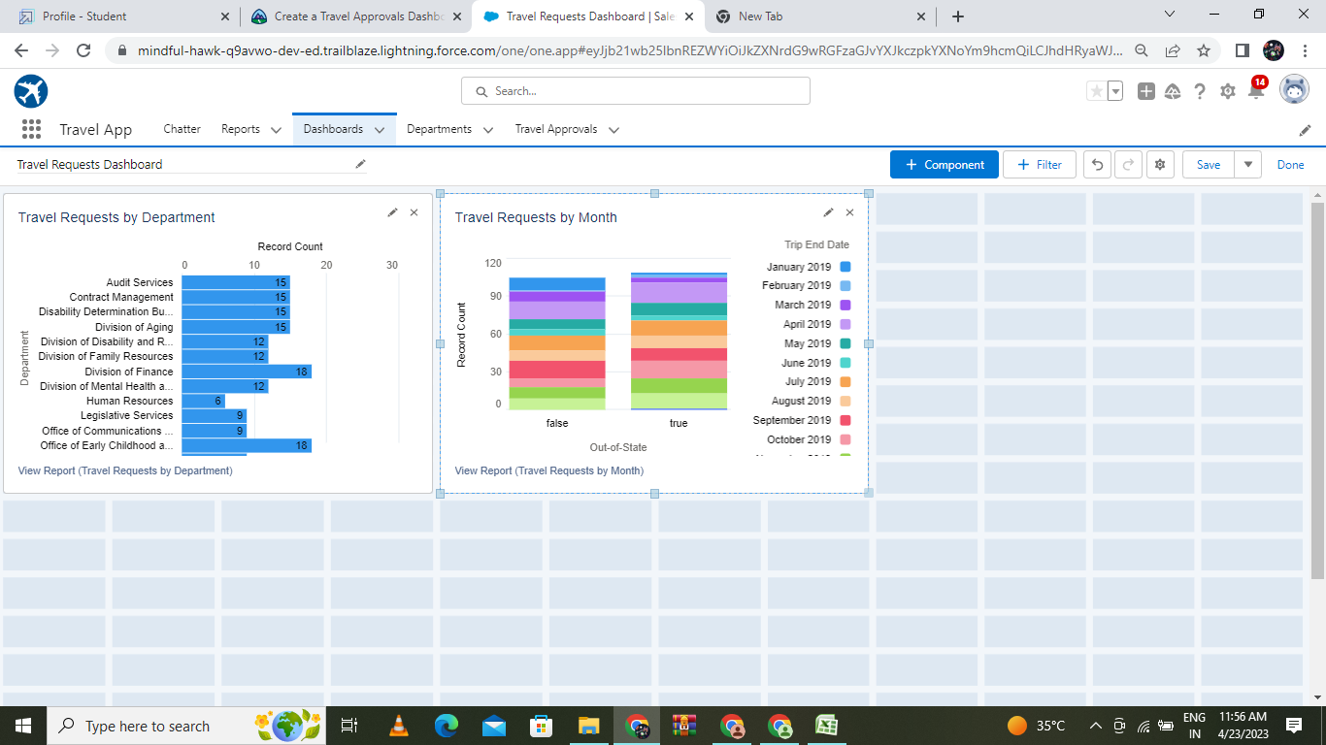

1. Trailhead Profile & Public

Team lead – https://trailblazer.me/id/kanik121

Team member 1 – https://trailblazer.me/id/gomam10

Team member 2 – https://trailblazer.me/id/deivv

Team member 3 – https://trailblazer.me/id/mmanimaran4

1. ADVANTAGES & DISADVANTAGE

Advantages

* Travel opportunities with work will allow you to see places that you may not have sees before and experience new countries and cultures.
* Many employers are also flexible around holidays when travelling and will allow you to schedule in some sightseeing time around your work.

Disadvantage

* Expensive – Roundtrip tickets, hotel accommodation, meals and reservations.
* They are the popular expenditures of executives out on a small business trip
* Though these expenses usually do not come inexpensive, business travel also lasts to get a couple of days.

1. APPLICATIONS

* User personal area. A travel app is a tool for personal use.
* Third-party data aggregation.
* Search function and filters.
* Navigation and geolocation.
* Booking function
* Itinerary planner.
* Notifications on important events.

1. CONCLUSION

Here, I have come to the end of the project on the topic Build a Employee Travel Approval Application for corporate structure.I tried my best to include all the necessary points that are required related to the given topic.

1. FUTURE SCOPE

Studying tourism can open up a number of lucrative job options, from becoming a travel agent to working in hotel management. Topics like destination marketing, customer service, and event management are frequently covered in tourism courses.